Participant details:
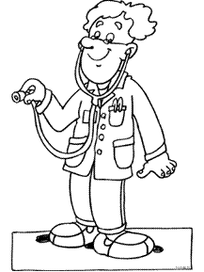

First name:
Infix:
Last name:
Address:
Date of birth:
Phone number:

Health declaration:

Health Insurance
Name:
Number:

Doctor
Name:
Phone number:

In case of an emergency
Name:
Phone number:

Does the health require special care?
Yes / No, If yes which one?

Are there some kind of health problems, like asthma, hay fever, eczema, epilepsy or other complaints?
Yes / No, If yes which one?

Are there use of medications that we should be aware of?
Yes / No, If yes which one?

In the event of an emergency, at the discretion of a doctor, I give permission for my son/daughter to be admitted and treated in a hospital, without my prior knowledge, if it was not possible to contact me in time.

Date: ____ - ____ - 2024

